Data Analysis and Algorithm

Practical 6

Write a program to implement Huffman’s code algorithm.

Date.: 11-10-21

Name – Yash Vasudeo Prajapati

Rollno - 022

MSc. Computer Science

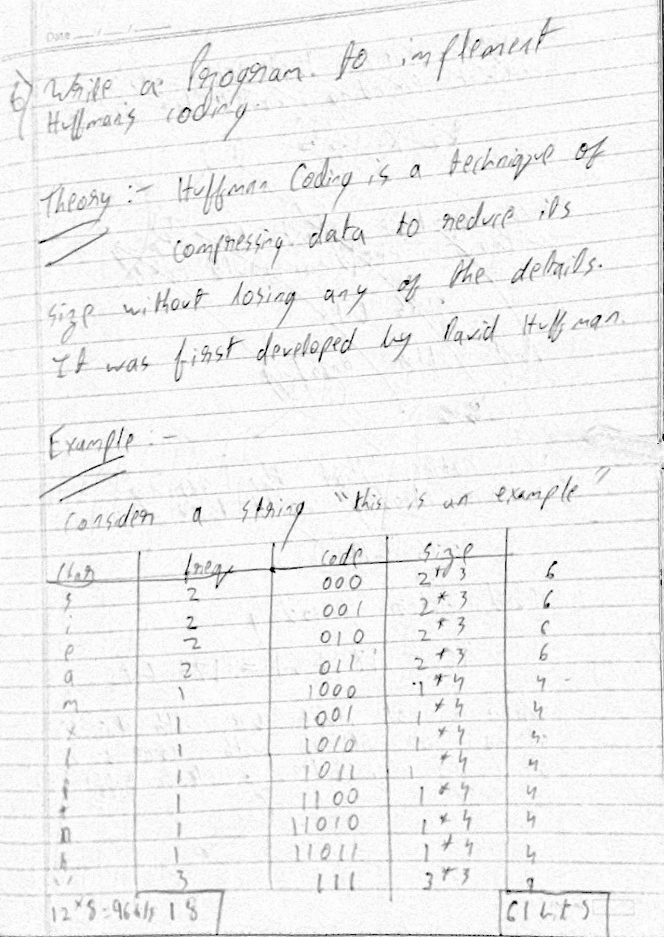

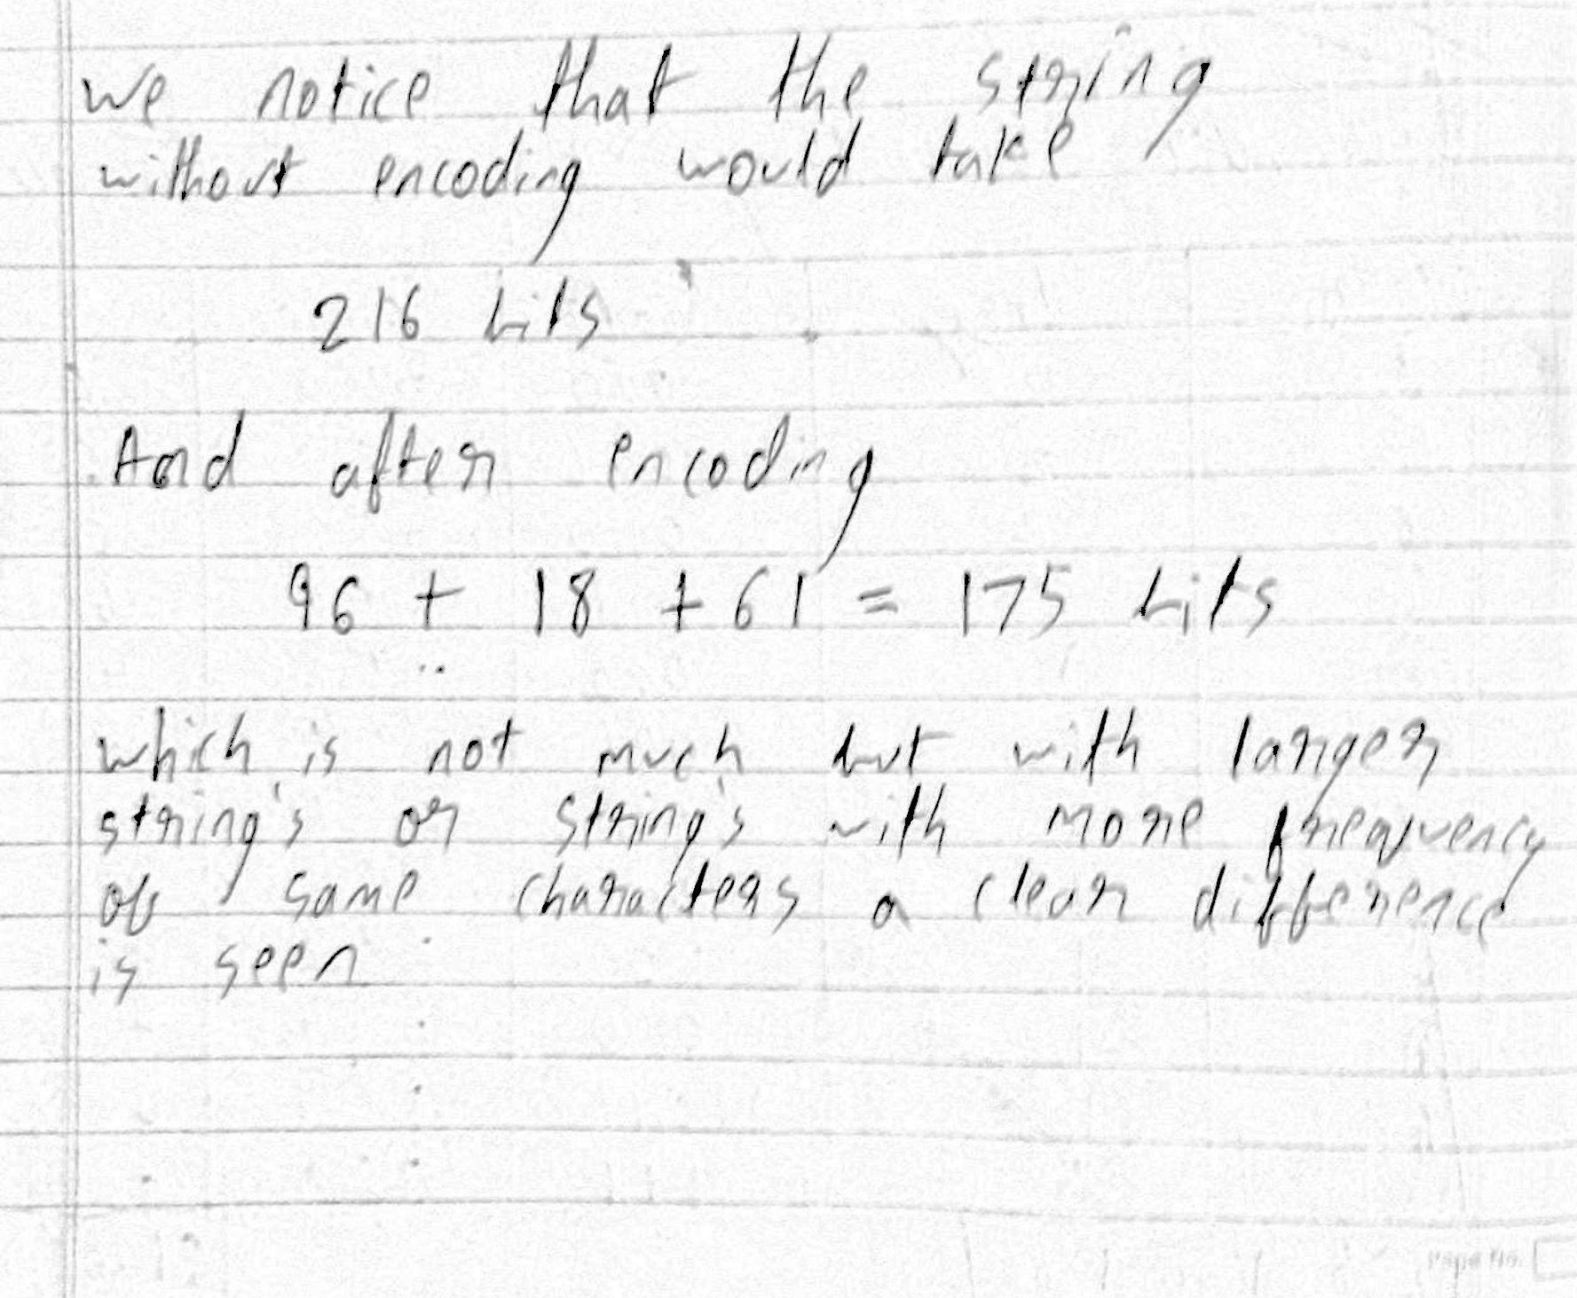

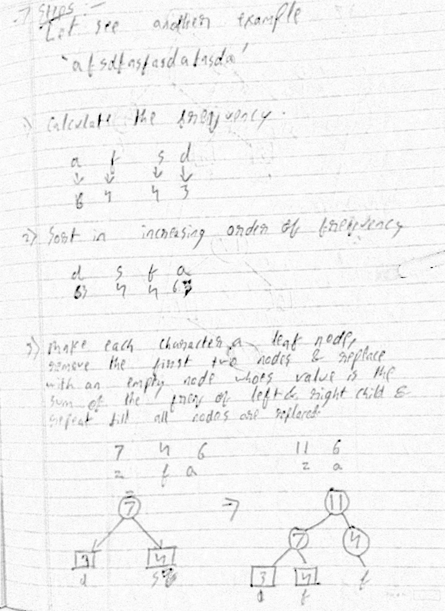

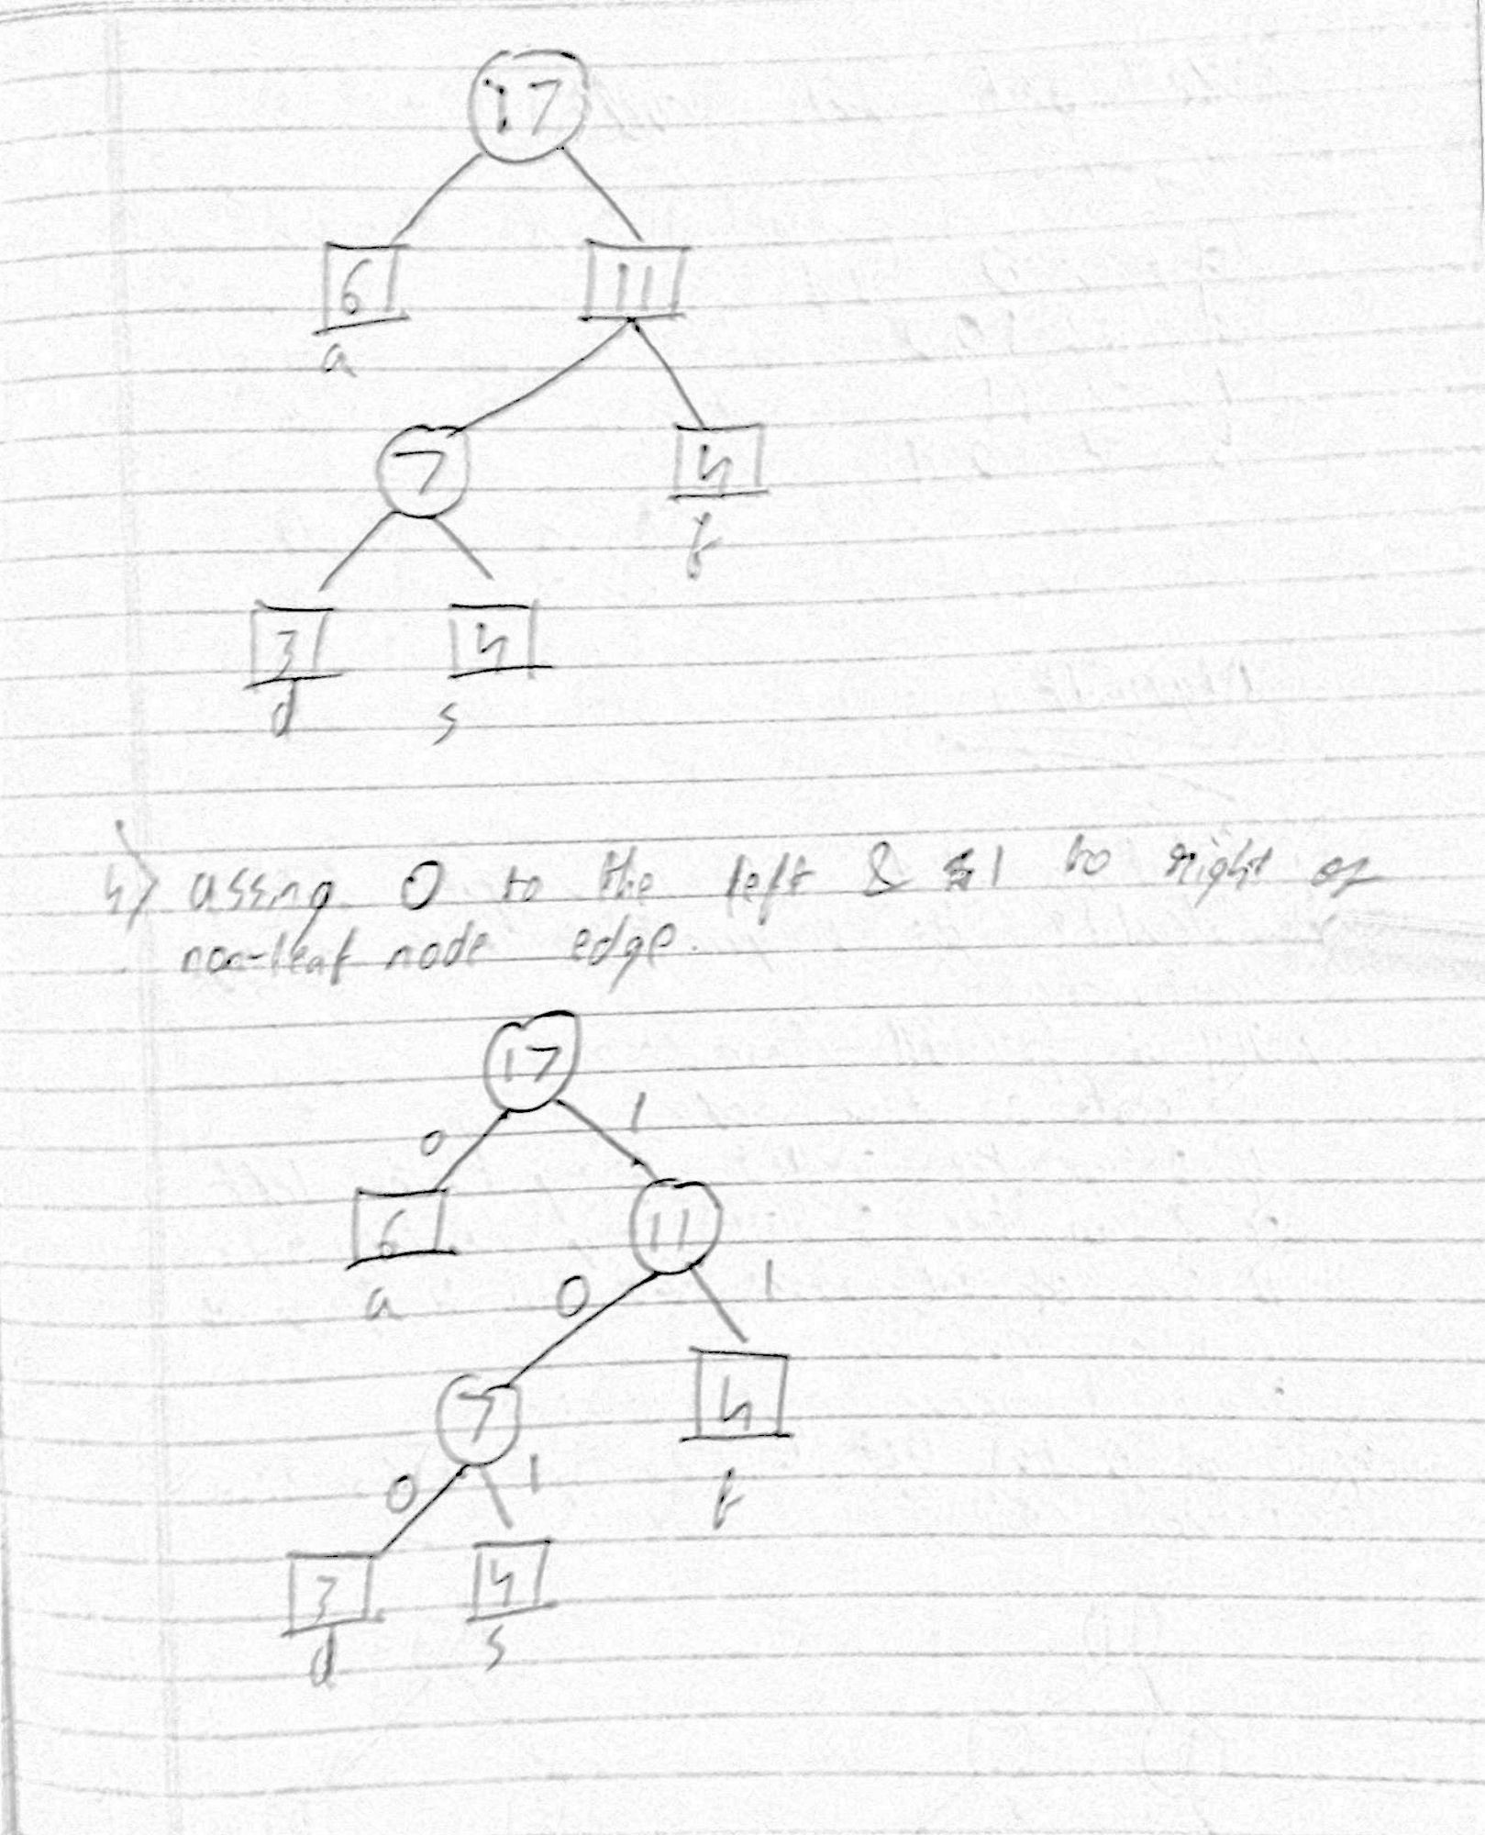

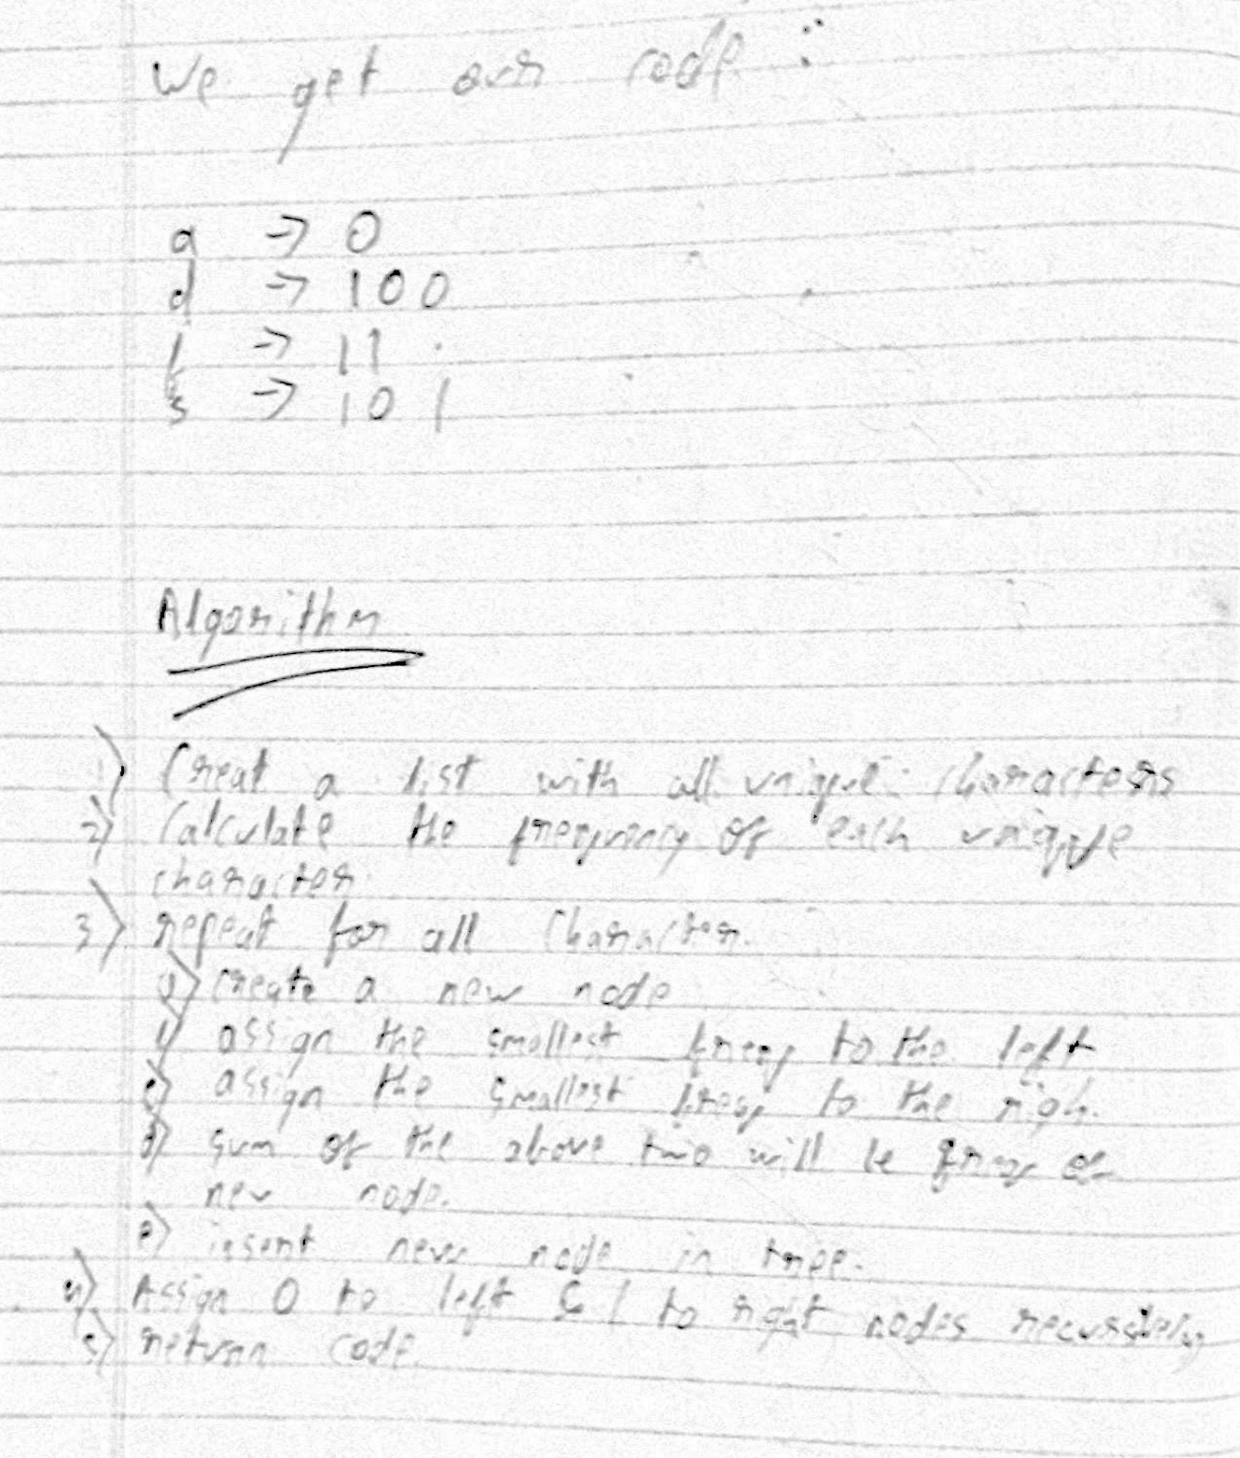

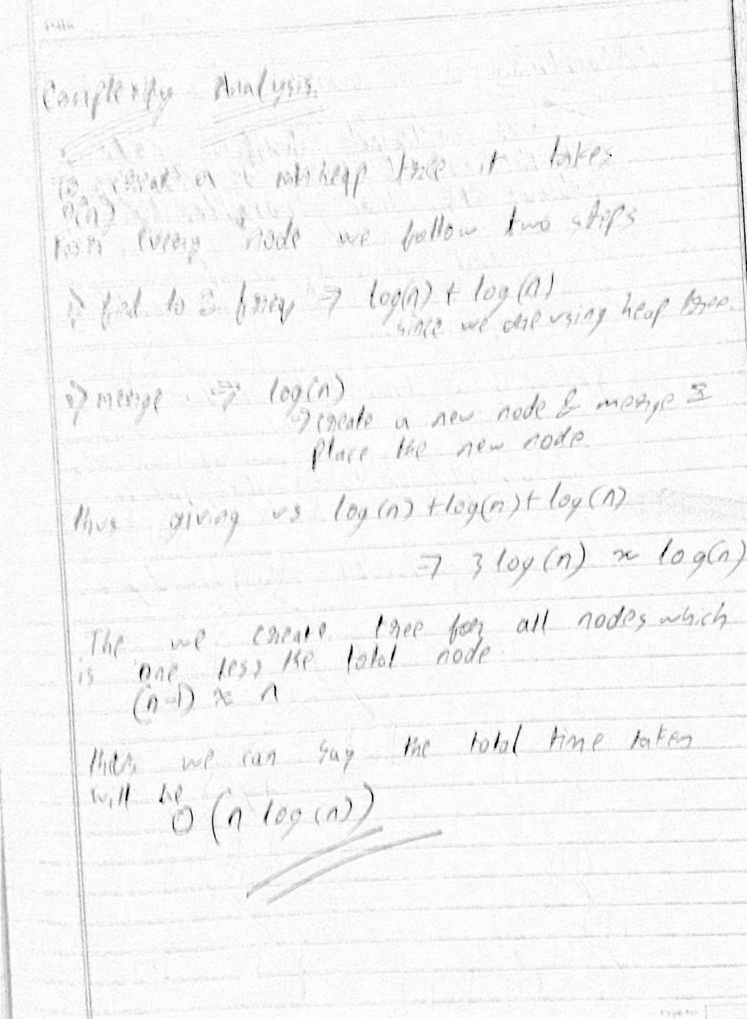

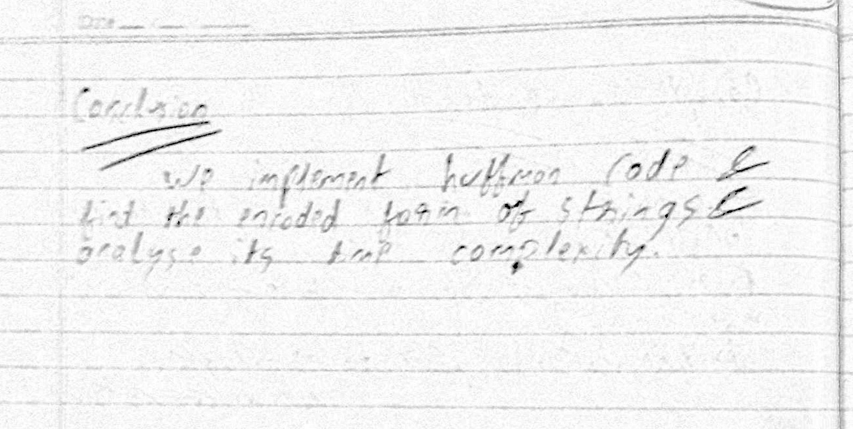

Program

class NodeTree(object):

def __init__(self, left=None, right=None):

self.left = left

self.right = right

def nodes(self):

return (self.left, self.right)

# Main function implementing huffman coding

def huffman_code_tree(node, left=True, binString=''):

if type(node) is str:

return {node: binString}

(l, r) = node.nodes()

d = dict()

d.update(huffman_code_tree(l, True, binString + '0'))

d.update(huffman_code_tree(r, False, binString + '1'))

return d

# Calculating frequency

string = 'ACDSVDASCASDAW'

freq = {}

for c in string:

if c in freq:

freq[c] += 1

else:

freq[c] = 1

freq = sorted(freq.items(), key=lambda x: x[1], reverse=True)

nodes = freq

while len(nodes) > 1:

(key1, c1) = nodes[-1]

(key2, c2) = nodes[-2]

nodes = nodes[:-2]

node = NodeTree(key1, key2)

nodes.append((node, c1 + c2))

nodes = sorted(nodes, key=lambda x: x[1], reverse=True)

huffmanCode = huffman_code_tree(nodes[0][0])

print(huffmanCode)

